*Web Technologies I*

*TERM PROJECT*

INSTRUCTOR: Rubem Linn

CLASS: Summer 2018 (CSD 1113_9)

Date: 7th Aug, 2018

Students Name: Himanshu Patel (C0735691)

Shubham (C0737342)

Sujalkumar Patel (C0735603)

Deepak Punia (C0739472)

**Section 1 – Planning Checklist**

- What is the Purpose of the Website?

* Purpose behind developing this website is to introduce and revive forgotten handicraft of Kutch to world and take it to global level which will in turn help to expand the business and also increase employment to the artist which are turning towards other source of income to make their end’s meal. It also a good platform to show Gujarat’s (A stat of India) culture to the world.

- Who is the Target Audience?

* Handicraft lover from all-around the world who have keen interest in hand crafted artworks so they can join us to the cause.

- How many pages will be included in your website?

* There are four pages in our website

1. **Home page** - A basic introduction to handicraft of kutch through video documentary and text description.
2. **Article page** - A brief introduction to handicraft of kutch showing various types of art work made through Images gallery and text description with social feeds of Facebook and Instagram.
3. **About page** – About the team of activist involved in this cause with their names.
4. **Contact page** – Contact form so people who want to join this cause can message us or can give us feedback on how can we improve.

- What graphics will you use on the website?

* We will be using Video, Images and Social Media Feeds related to handicraft and Website Logo.

- What colours will you use on the website?

* White as it is considered to be the color of perfection as the art work of kutch seems perfect and Light grey to contrast white in some are we are using black fonts.

- What font styles will you use within the website?

* Google font – Sofia, Monteserrat
* Inbuilt font – Arial, Helvetica, Sans-serif

- What features will be displayed on the webpages?

* Responsive Layout
* Accessibility
* Maps
* Embedded videos
* Social media feeds

.

**Section 2 – Content Requirements**

Implemented in Project

**Section 3 – Structure Requirements**

**Sitemap:**

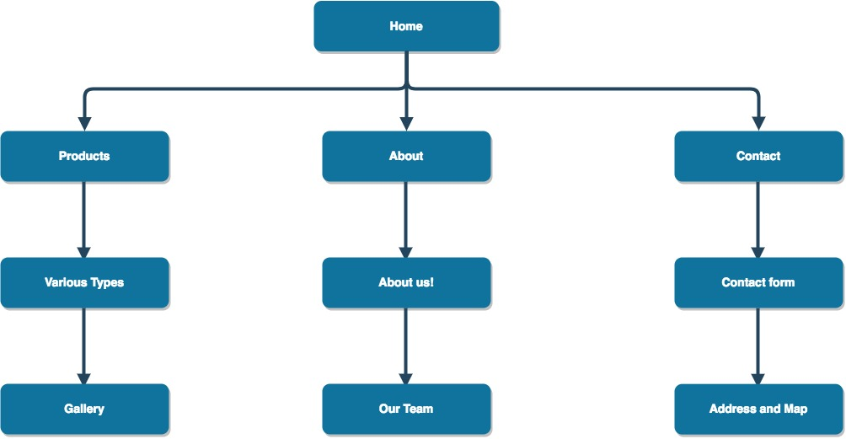

**Wireframe: Home - Desktop**

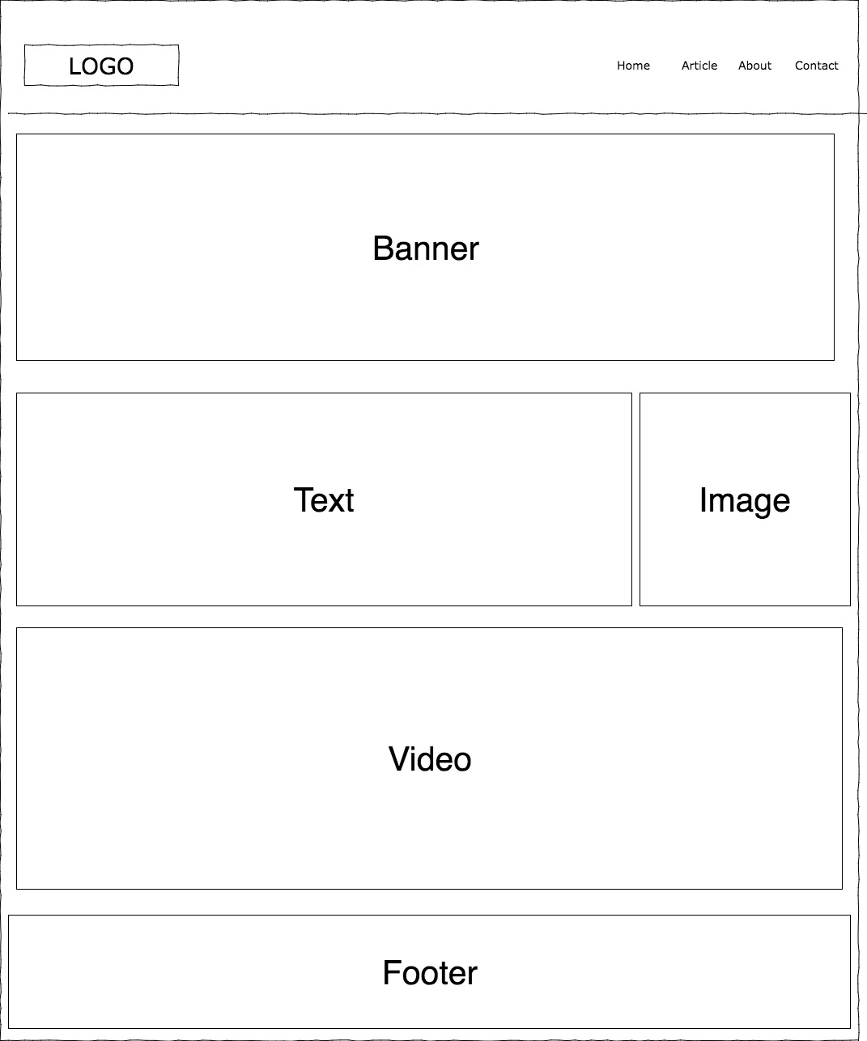

**Wireframe: Home - Tablet**

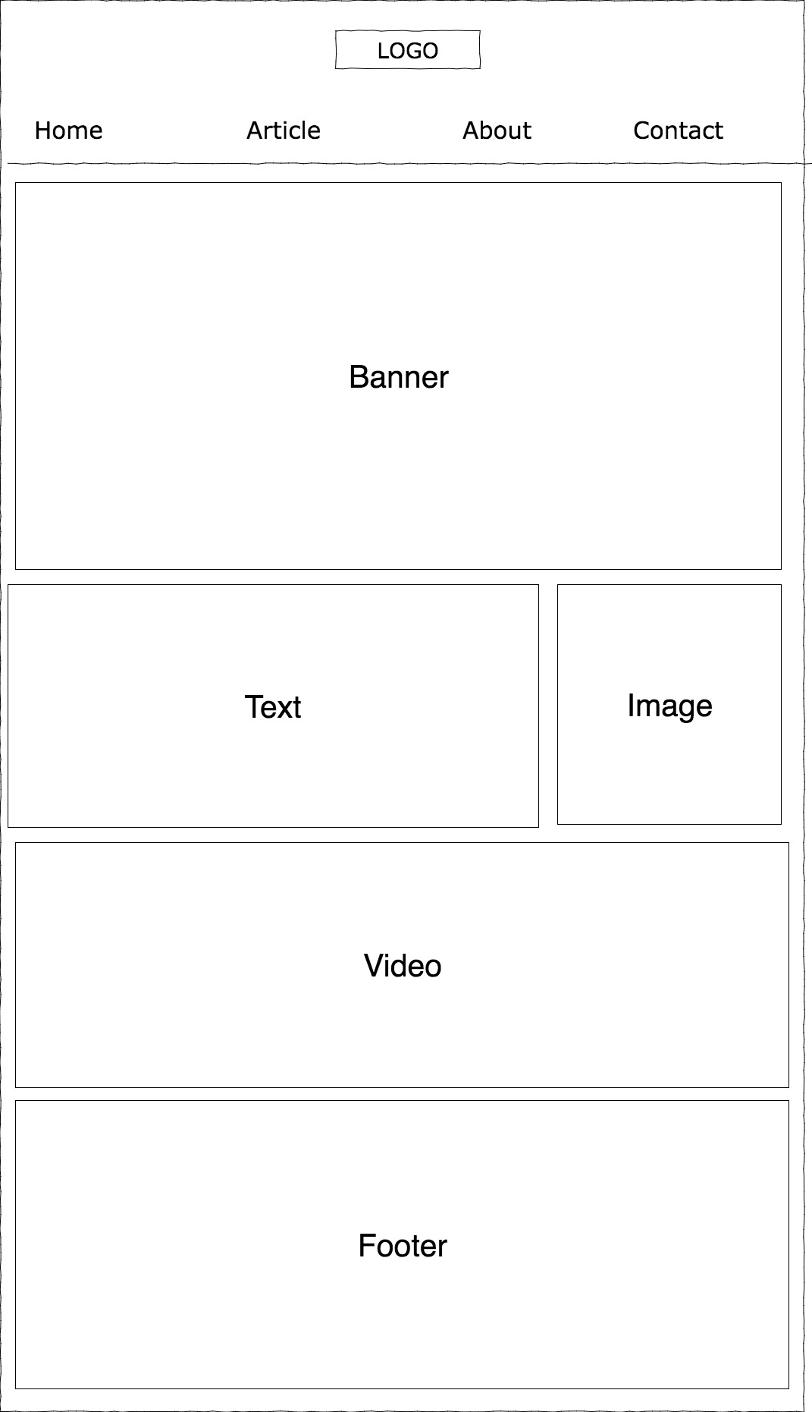

**Wireframe: Home - Mobile**

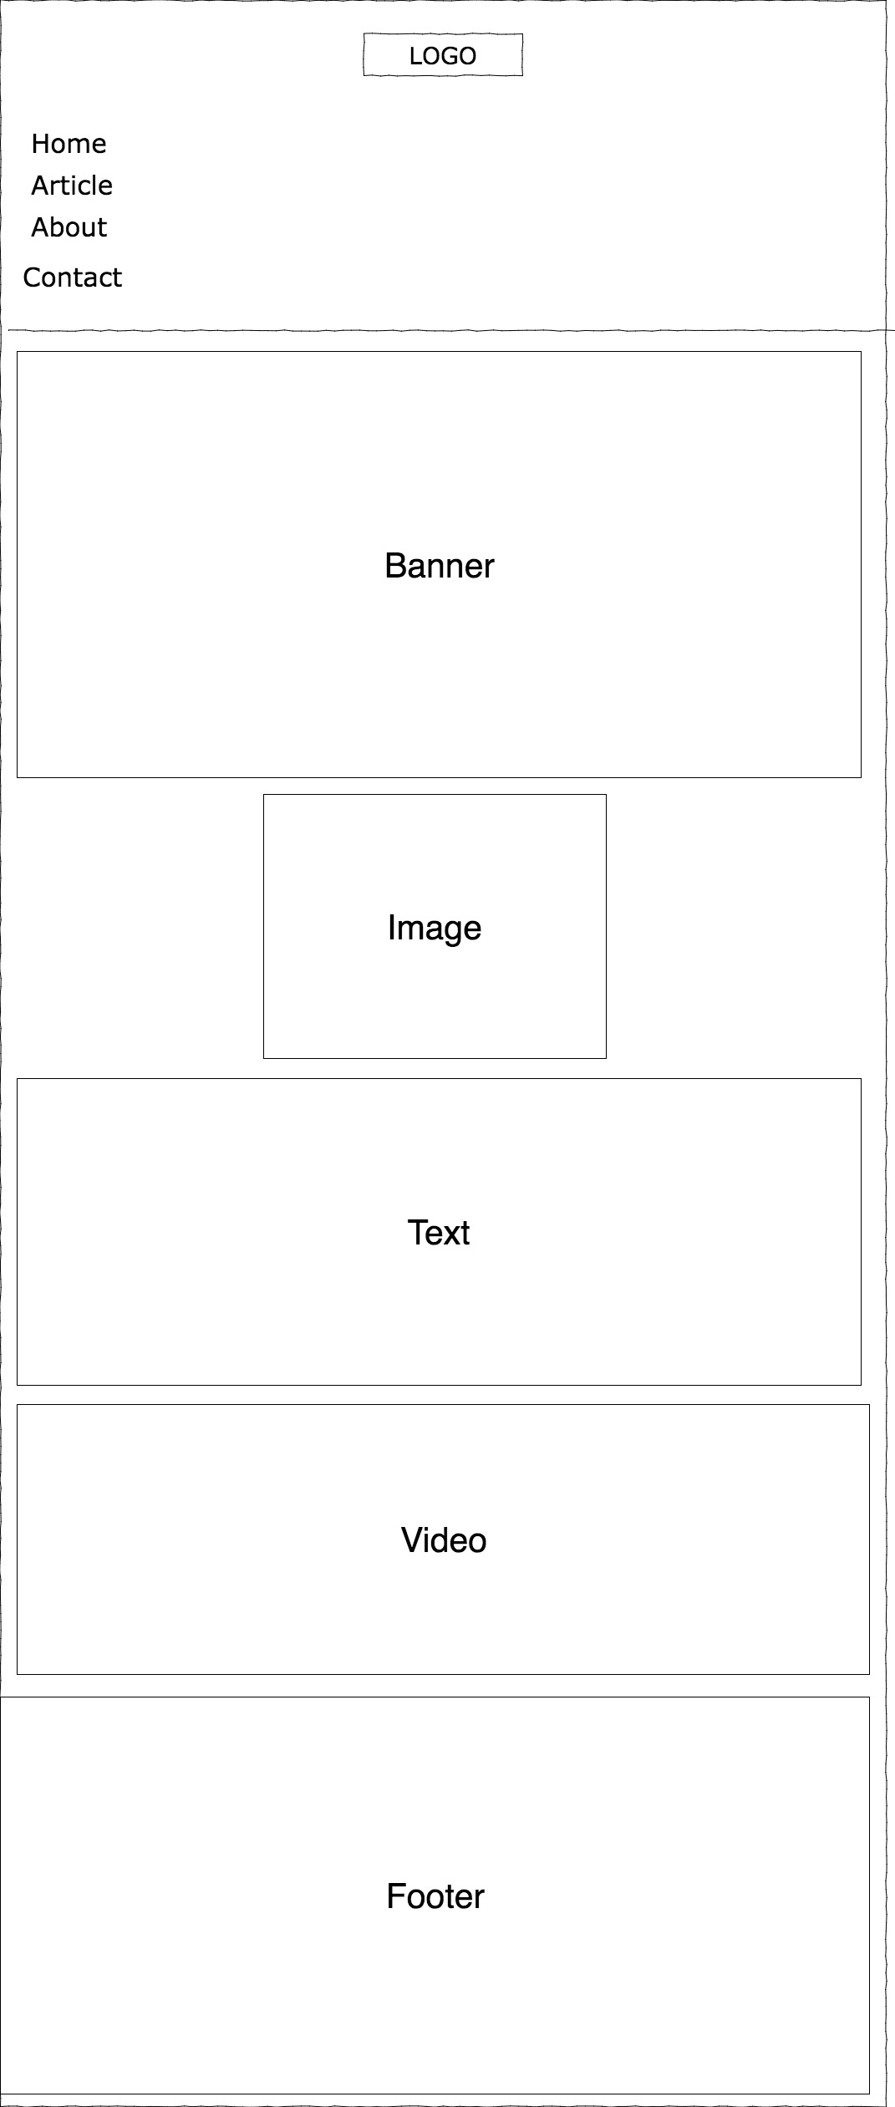

**Wireframe: Article – Desktop**

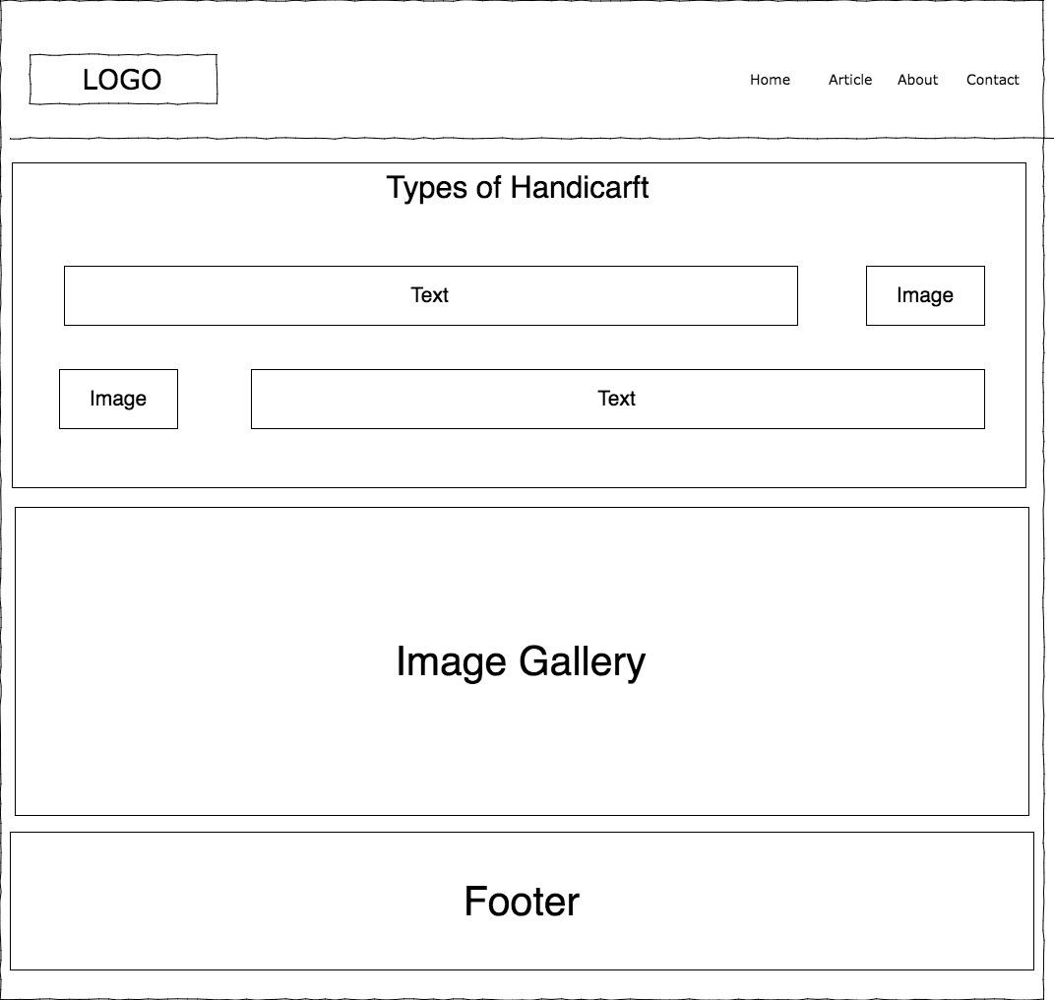

**Wireframe: Article – Tablet**

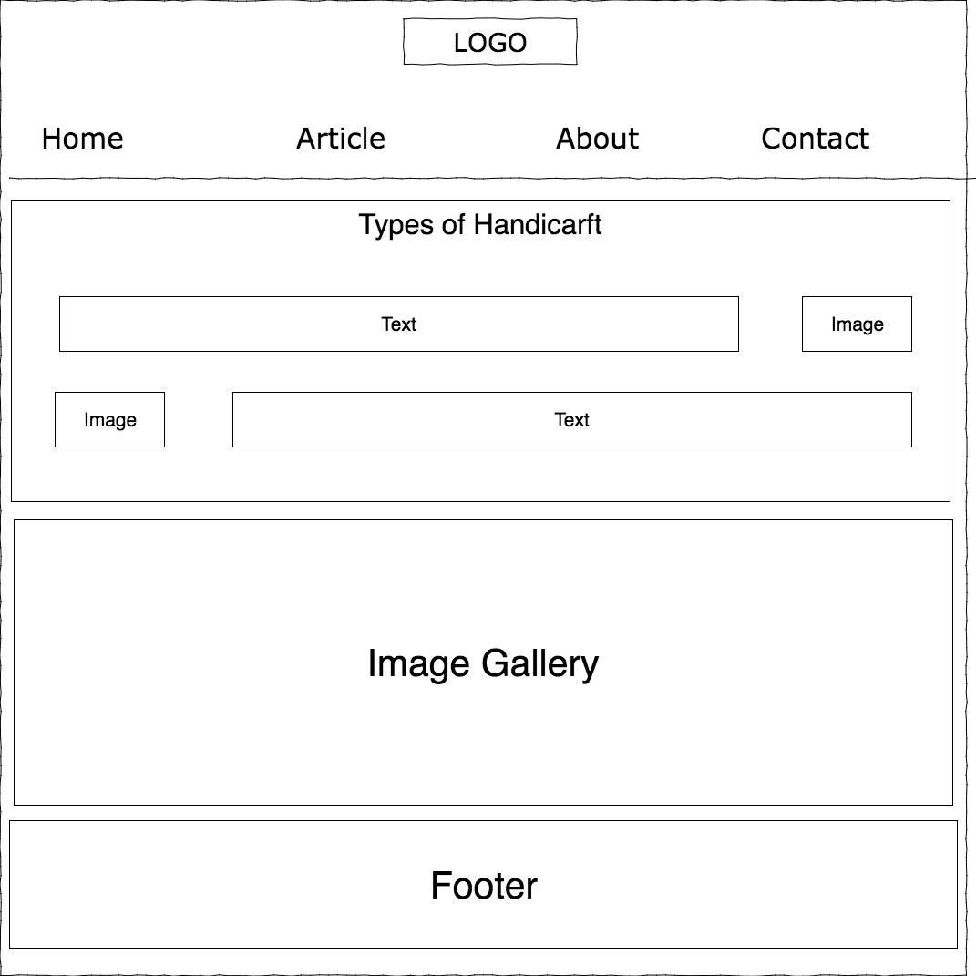

**Wireframe: Article - Mobile**

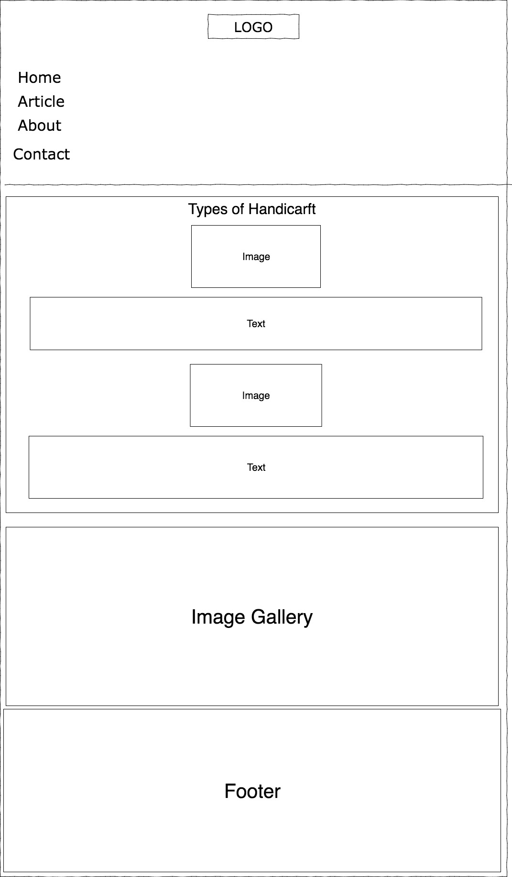

**Wireframe: About - Desktop**

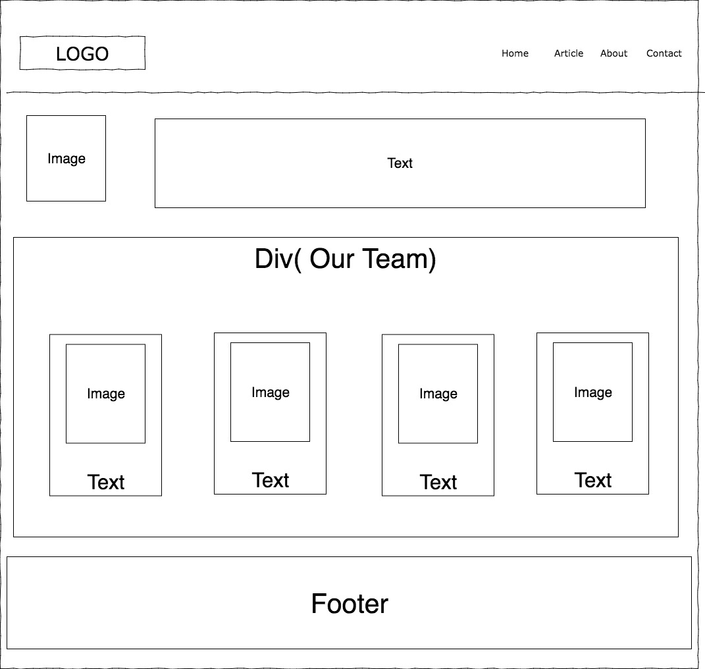

**Wireframe: About - Table**

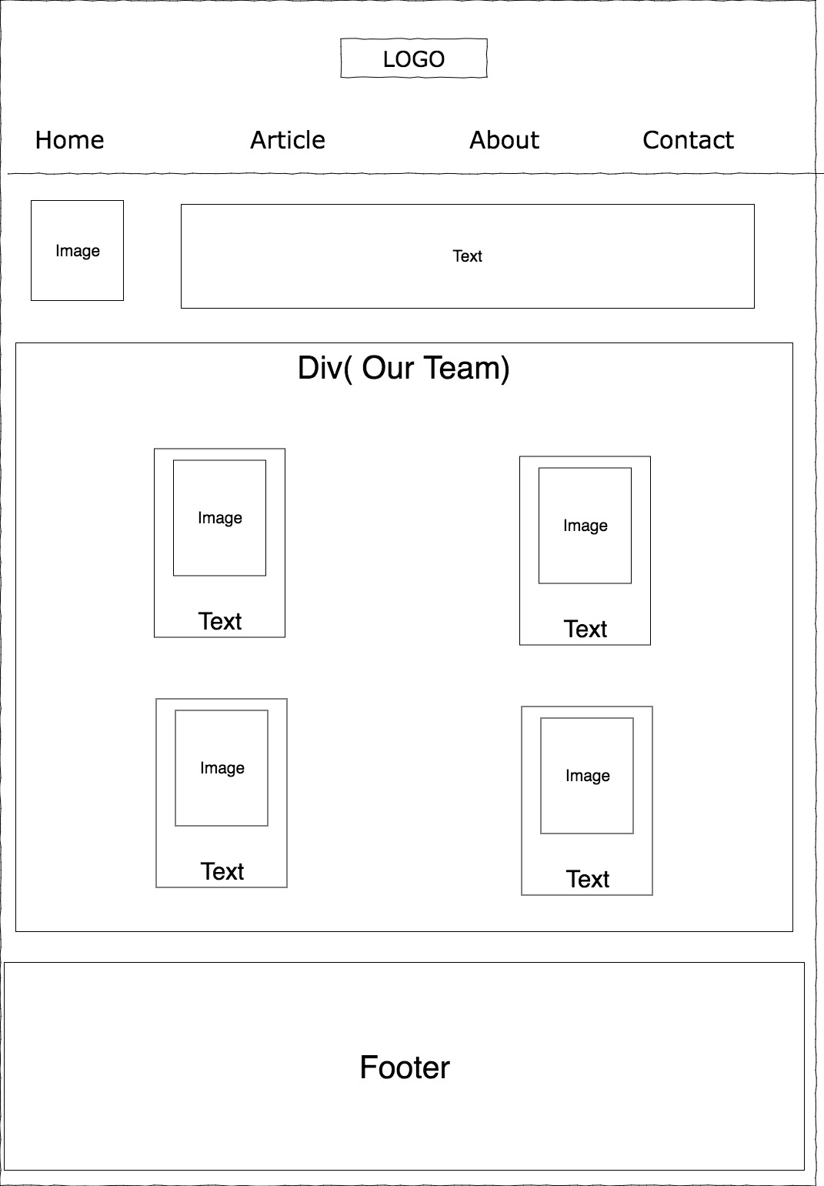

**Wireframe: About - Mobile**

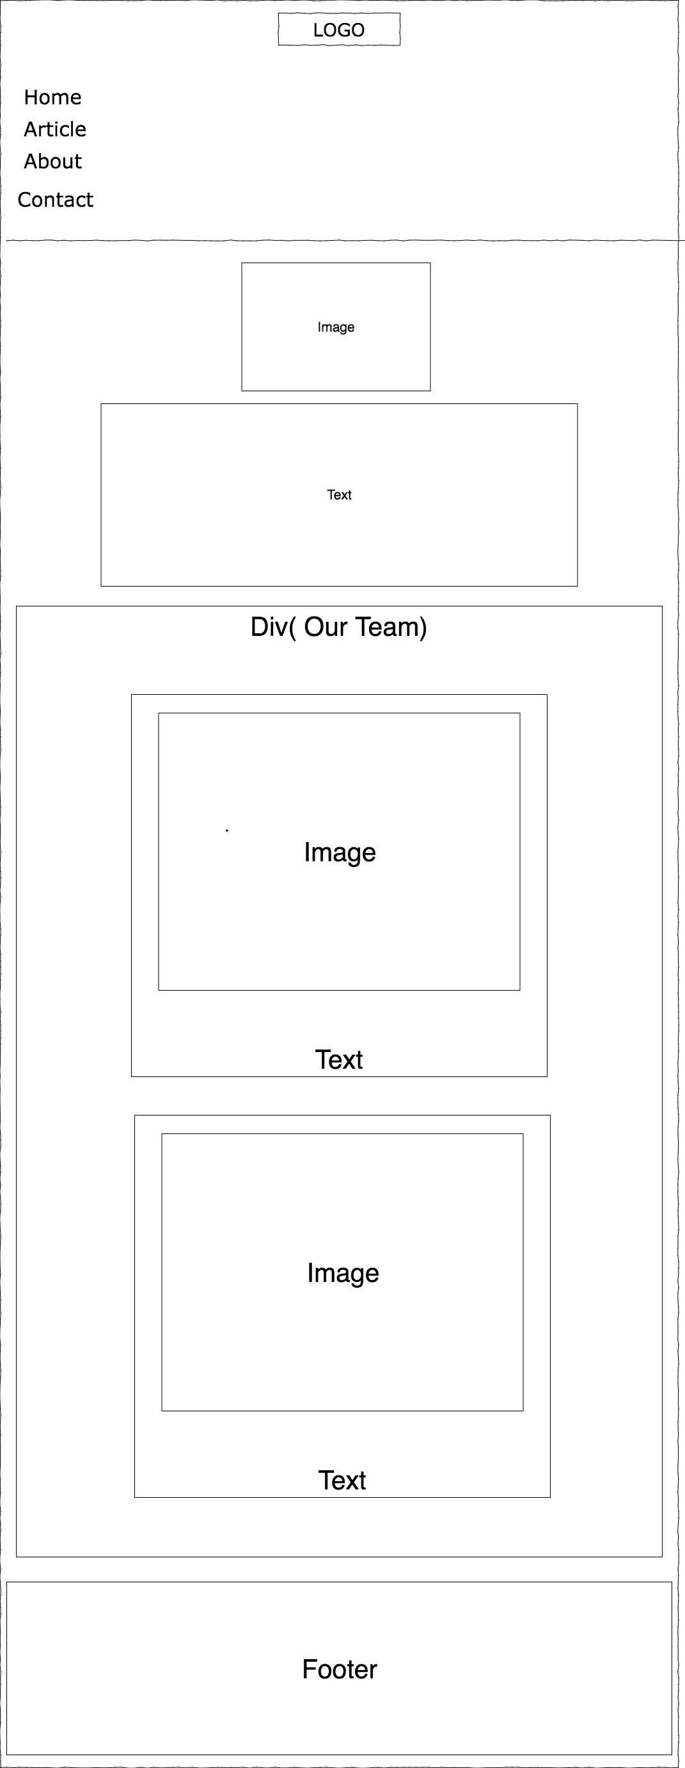

**Wireframe: Contact – Desktop**

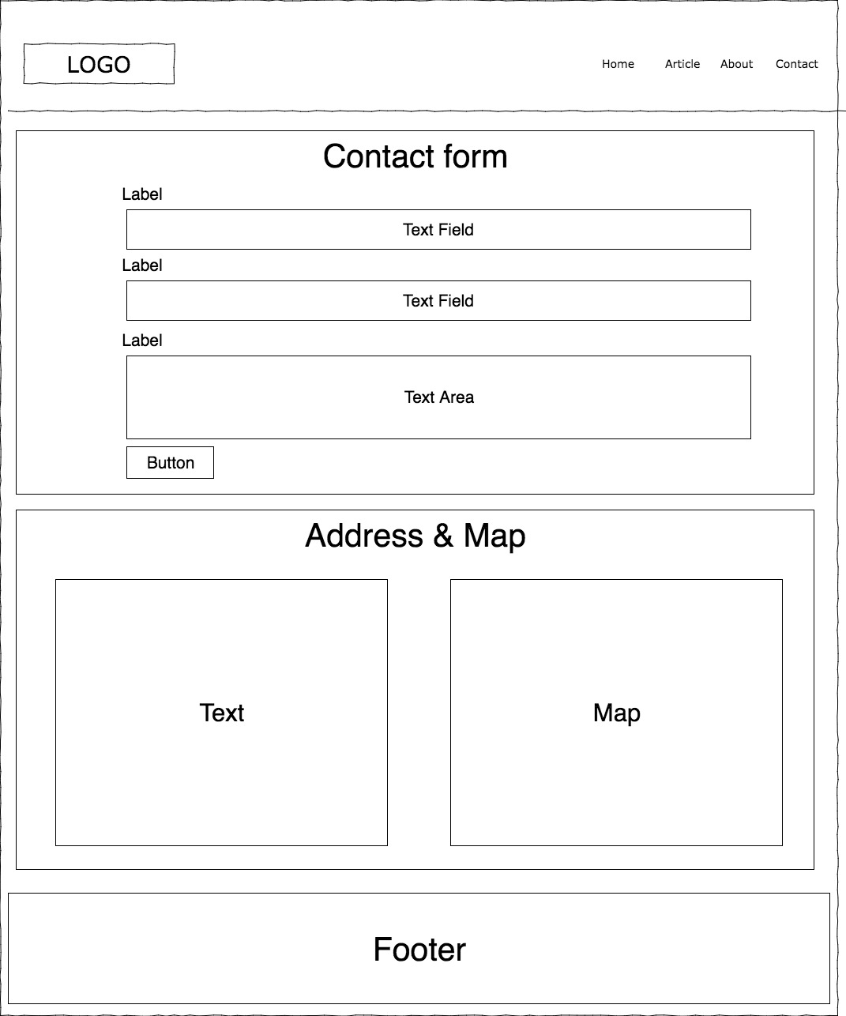

**Wireframe: Contact – Tablet**

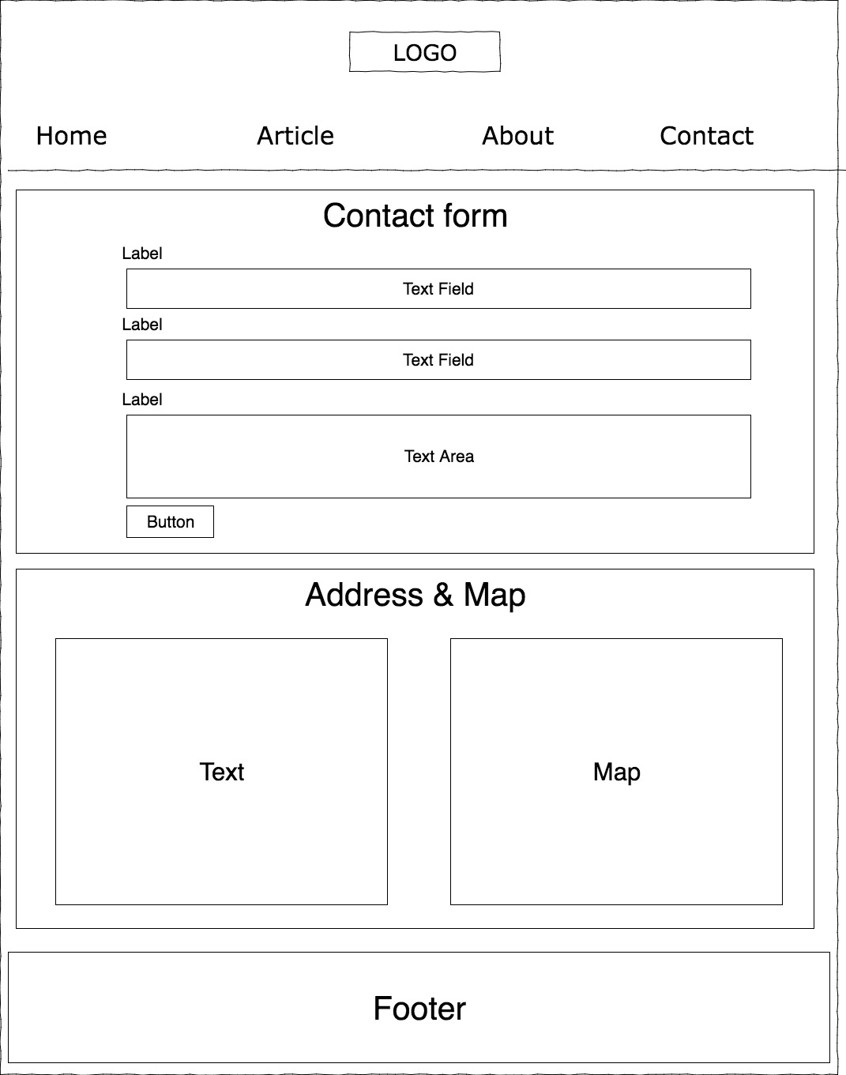

**Wireframe: Contact – Mobile**

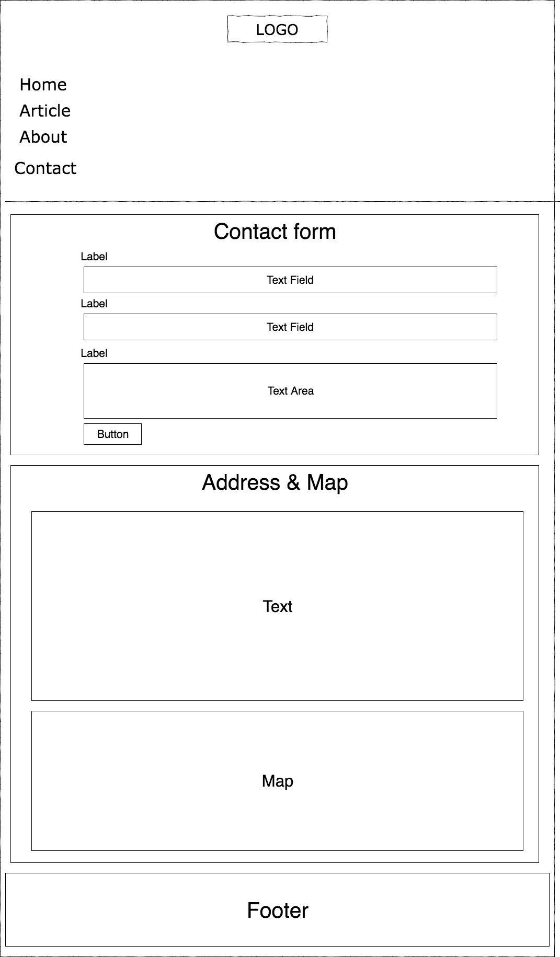

**Section 4 – HTML Requirements**

Implemented in Project

**Section 5 – CSS Requirements**

Implemented in Project